# Microsoft Azure

Microsoft Azure is Microsoft’s cloud platform. It allows companies, programmers, and students to build applications of all sizes. It provides hosting for web services (in all types of programming languages), access to various database engines, is a hosting platform for Virtual Machines (all operating systems), provides interfaces for machine learning and other cloud processing.

# Get your license:

* <https://azure.microsoft.com/en-us/free/students/>

You will need to log in with your Algonquin Live account to access the service. Once you log in you have access to almost the entire platform.

# Before we get started

By accessing the link above, you have been granted a credit of 100$ dollars for the next 365 days. The services provided to you are not free! If you deviate from the instructions, you may run out of money before the end of the class and will have to find a way to make up that difference.

# Creating Web Applications

To submit your web applications, you will need to create websites on Azure.

1. Navigate to the Azure portal
   1. <https://portal.azure.com>
2. Log in with your Live AC account
3. Click ‘+ Create a resources’
4. Select ‘Web’
5. Select ‘Web App’
   1. Once done you will be taken to the ‘Web App Create’ blade
6. Subscription should say ‘Azure for Students’
7. Resource Group
   1. I usually just use the same as the app name (for example: afrasialab2)
   2. Create new if needed
8. Enter an app name
   1. For example: afrasialab2
   2. Note that this name will need to be unique. If someone else uses the name you will have to pick another.
9. Publish, leave as Code
10. Runtime stack? Guess what, it is .NET core, and what version would you choose?
11. OS, leave as Windows
12. Region, select Canada Central
13. App Service Plan/Location
    1. This should say ‘(New) ASP-afrasialab2-XXXXXXXXX
    2. Keep the sku and size, F1, 1GB
       1. This was uniquely created for you. If it is not there you will need to create your own plan. Be sure to use the ‘F1 Free’ tier, otherwise it will cost you money
14. Create

It will take a few moments to create your new website. Once created you’ll have an empty website available the URL: <http://afrasialab2.azurewebsites.net/> Where afrasialab2 is the name you gave to the app.

# Deploying an Application

When you have completed your work on a lab or assignment, you can now deploy your application to Azure.

1. In Visual Studio, open your project, right click on the Project in the Solution Explorer, and click ‘Publish’
2. A new ‘Publish’ dialog will become visible
3. Select the publish target: Azure
4. Select specific target: Azure App Service (Windows)
5. You will need to log in using Live AC account
   1. If you are logged in as another account, you will need to add your Live AC account
   2. If you are logged in with your Live AC account, you do not need to do anything
6. Subscription, Azure for Students
7. View, Resource Group
8. In the big box at the bottom you should see a list of your Web Apps created in Azure
   1. You can also create the app directly from this dialog if you have not gone to Azure to create a Web App. You can use this mechanism if you would like but make sure to use the free tier
9. Select the Web App you want to deploy too
   1. Select the item with the blue world icon for it to work correctly. Selecting the top-level folder will not do anything
10. Click ‘Finish’
11. Once you click Finish, Visual Studio reaches out to windows azure and pulls down an Xml document called a ‘Publish Profile’. This document will prefill all the settings needed to deploy the application  
      
    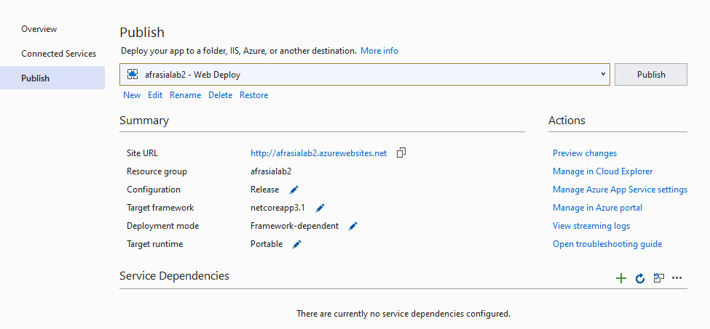
12. Click ‘Publish’
    1. This will deploy your code and when ready launch the web browser targeted at your new Web App

Notes

* If you are having problems logging in to Microsoft Azure from WITHIN Visual Studio, you can deploy using an alternate method
  1. Navigate to the Azure portal
     + <https://portal.azure.com>
  2. Log in with your Live AC account
  3. Using the navigation items on the left of the dashboard click ‘App Services’
  4. Select the App you wish to deploy, you will be taken to the applications ‘Dashboard’
  5. On the dashboard you will find ‘Get publish profile’ at the top of the dashboard
     + Download and save the file
  6. Open Visual Studio and your Project
  7. Right Click on your Project and click ‘Publish’. The Publish dialog will appear.
  8. Select the publish target: Import
  9. Import the Publish Profile document you downloaded earlier.
  10. After importing you will see a dialog like this:



* 1. Click ‘Publish’
     + This will deploy your code and when ready launch the web browser targeted at your new Web App